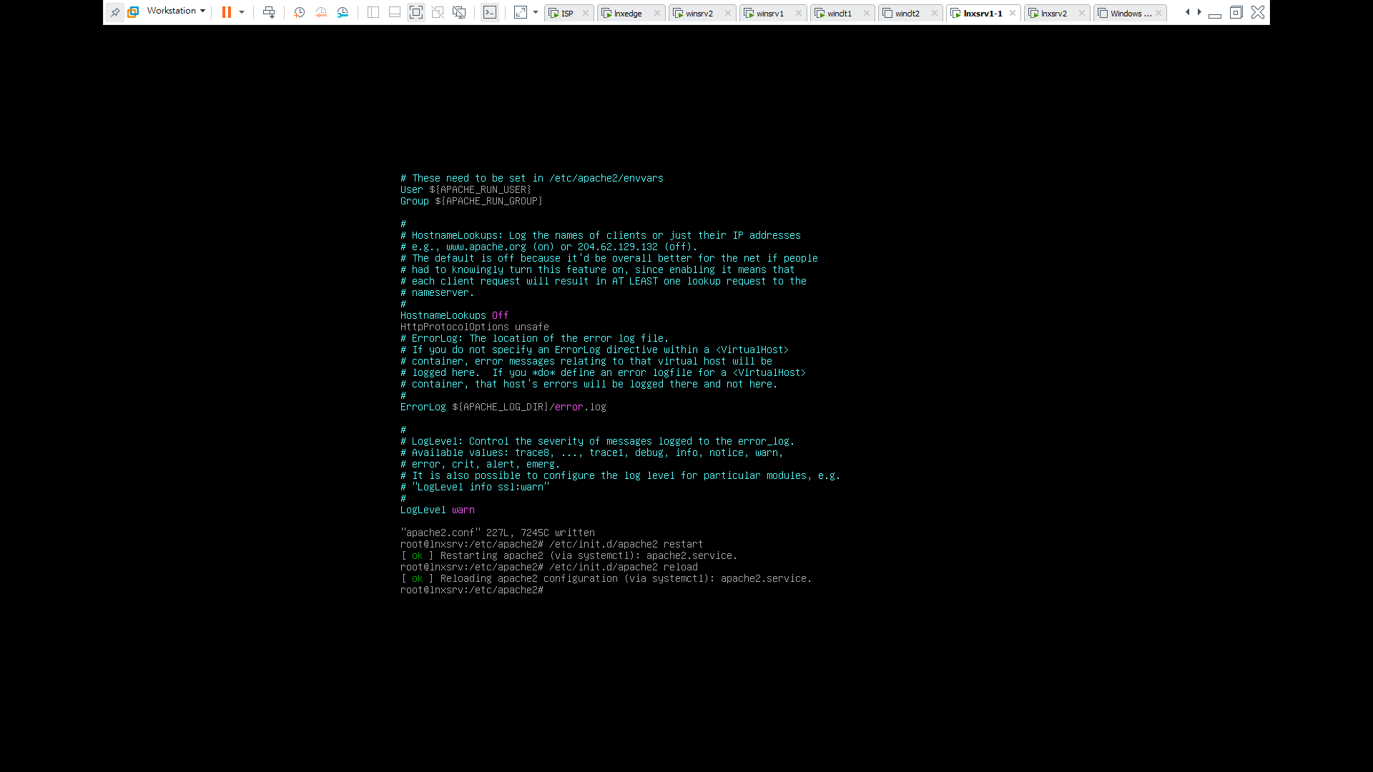

Apache2 domain underscore

Add line

HttpProtocolOptions Unsafe